Researching and Organizing Your Paper:
The Note Card System
http://depts.gallaudet.edu/englishworks/writing/notecard.html
When you are faced with starting a research paper, the most important part of researching and beginning to write is ORGANIZING the information and your thoughts. If you are not organized, it will take considerably more time to write the paper. To make it easy on yourself, you can use an index card system as you gather information. With this method, you categorize the information you find by topic. For each topic, you could have any number of cards from several different sources. Later, as you write your paper, each card topic becomes a body paragraph (supporting idea) in your paper.
Researching
As you find interesting facts about your topic during your research, you should write them down. Each sentence or idea that you find should be paraphrased (summarized in your own words), and written on a card. In order to keep your ideas in order, and to remember where you found the ideas, there are four items that you should include on the index card, as you will see below.
Here is a sample card:
Click on each card item for an explanation.
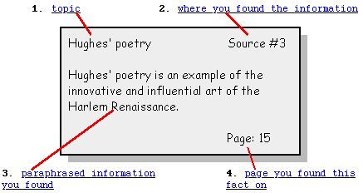
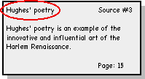
1. The card topic is the title for the kind of information on the card. The card topic is a name that you make up yourself. Think of it as the title, or main idea of the card. After writing down the information, figure out how you could briefly categorize, or title it. For example, if you are writing a paper on the life and works of the poet, Langston Hughes, you may have cards with topics such as:
- Hughes' upbringing
- Hughes and the Harlem Renaissance
- Hughes' influences
- Hughes' poetry
- Hughes' political beliefs
- Hughes' influence on America
Although it may seem tedious to give each note card a topic name, it serves two purposes:
- It keeps you focused in your research. You will be less likely to write down unnecessary information (facts that are not related to your topic) if you are careful to write down the topic for every card.
- It is necessary to have these topics once you begin organizing your research.
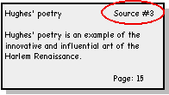
2. The source title is the name of the book, magazine, web cite, etc., in which you found the information. In the previous example, the source was given a number, instead of writing out the entire title. You could write out the title on each card , or simply list your sources on a separate sheet of paper, like the example here. Number your sources on this list, and then use the numbers on the note cards to specify which source provided which fact.
Sample Source List
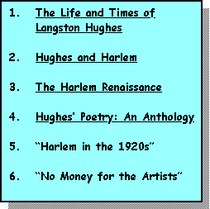
Remember! This is not a complete works cited, bibliography, or reference page. You will need to add the publication information and use the correct citation format (APA, MLA, Chicago/Turabian, etc.) for the formal works cited page.
3. Item number three is the paraphrased information that you found. It is helpful to paraphrase, or summarize, your research on the index cards while you are taking notes. If you are consistent in paraphrasing at this stage, then you will be certain not to accidentally plagiarize someone else's work. You will also have less work to do when you are actually writing the paper.
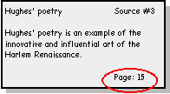
4. It is important to be accurate with the page numbers on your note cards, as you will need them for citations throughout your research paper. Be sure you know which form of citation your teacher requires. (For information on citing your sources, look at English Works! handouts on MLA, APA, and Chicago/Turabian Style citations).
Start Organizing
Once you have written the information down on the note cards, you only need to go back and organize your cards by topic. Group together all the cards that have the same topic (i.e. all the cards titled: "Hughes' Poetry" should be together). When you finish, you should have your cards in piles, one topic per pile. You can have any number of piles and any number of cards in each pile. The length and detail of your paper will determine how many piles and cards you have.
Your piles may look like:
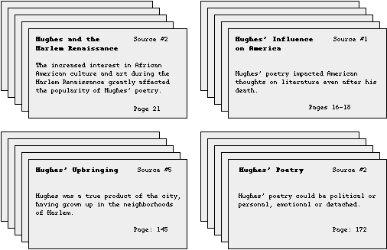
Outline and Start Writing
Once you have separated your cards into piles, each topic pile should become a body paragraph in your paper. That is the key to this system. If every topic directly supports your thesis statement, then each topic pile should become a supporting idea, body paragraph, or part of a paragraph in your paper.
But before you actually begin writing, you should make an outline of the order you want to present these topics in your paper. (For help making an outline, see the English Works web page on Pre-writing and Outlines). Once the outline is complete, use your note cards as guides and begin writing.
For further help on writing a research paper, refer to the English Works! web page Process of Doing a Research Paper, Guide to Developing Thesis Statements, and/or Guide to Writing Introductions and Conclusions.

